C219 Front-end Web Development

**Lesson 6**

**Assignment**

The School of Infocomm (SOI) Learning Portal is an online catalogue of coding lessons that provides you with an easy way to sign up for different programmes that would best fit your learning needs and preferences.

You are part of the front-end development team and you are required to code the home page of the SOI Learning Portal using Bootstrap. The requirements and wireframe have been provided to you below.

**Requirements**

1. Navbar
   1. Logo (Home)
   2. About
   3. Courses
   4. Contact
   5. Search box
   6. Notifications icon
   7. Avatar icon
2. Hero
   1. Title
   2. Description
   3. Two buttons
   4. Image
3. Three-column section
4. A row of cards
   1. Cards should have an image, title, course duration, instructor name and bookmark icon
   2. Four cards to be displayed
5. Footer
   1. Copyright text
   2. Privacy
   3. Terms
   4. Feedback
   5. Support

**Wireframe**

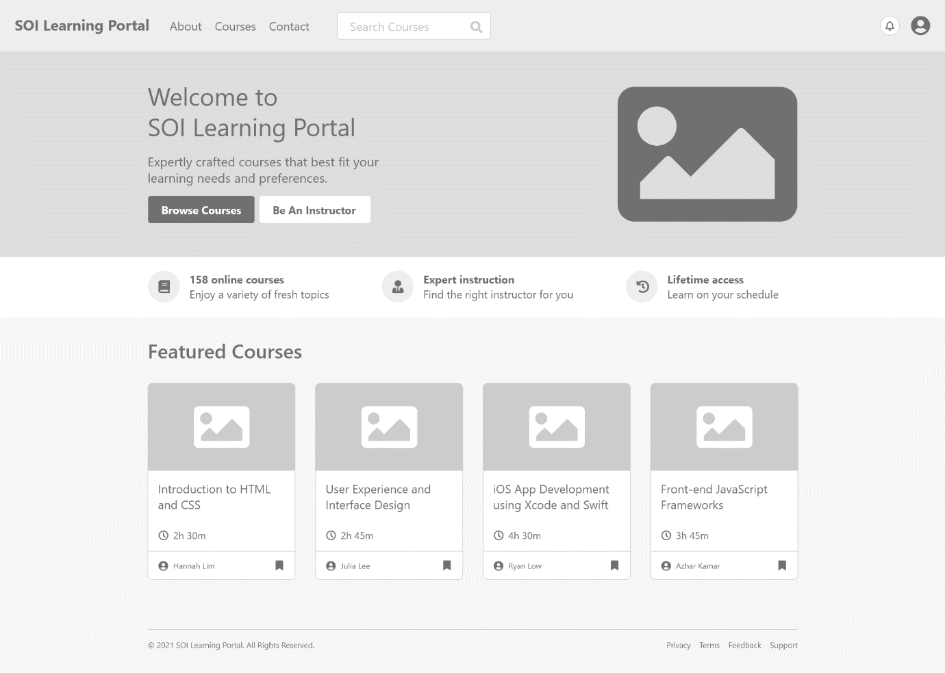

You can view the wireframe [here](https://xd.adobe.com/view/c104fc76-e65a-4893-9c41-e246a7d44fbc-9457/?fullscreen&hints=off) too.

The wireframe text can be found in **SOI Learning Portal Text.docx**.

You are to create or source for your own icons, graphics and images.